INDUSTRIAL TRAINING REPORT

**On**

**<Android Oreo App Development >**

**Submitted by**

**Vishal Singh**

**181500806**

Department of Computer Engineering & Applications

**Institute of Engineering & Technology**



**GLA University**

**Mathura- 281406, INDIA**

**2020**

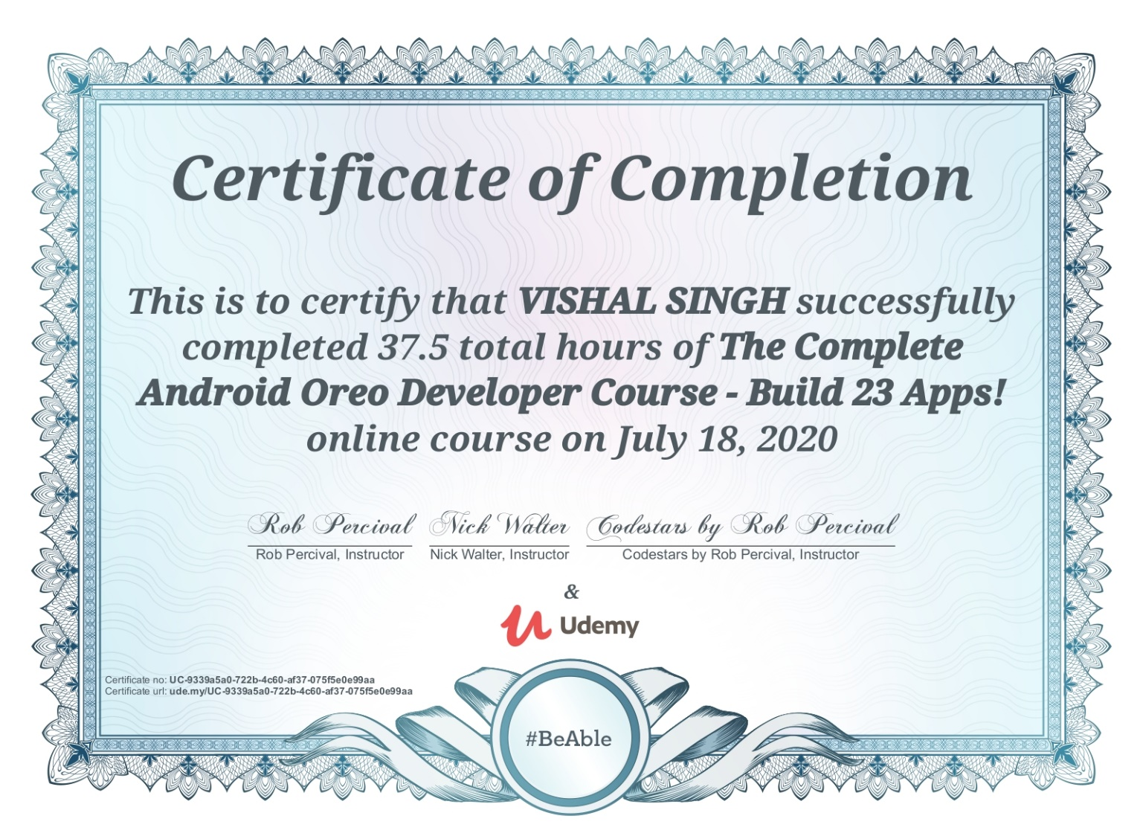



**Department of computer Engineering and Applications**

**GLA University, Mathura**

**17 km. Stone NH#2, Mathura-Delhi Road, P.O. – Chaumuha,**

**Mathura – 281406**

**Declaration**

I Vishal Singh hereby declare that the work which is being presented in the Industrial Training “**Android Oreo App Development”,** in partial fulfillment of the requirements for Industrial Training viva voce, is an authentic record of my own work carried under the supervision of “Udemy”.

Signature of Candidate:

Name of Candidate: Vishal Singh

Roll. No. : 181500806

Course: B-Tech (CSE)

Year: 3rd

Semester: V

**Student Information:**

|  |  |
| --- | --- |
| Name: Vishal Singh | University Roll. No. 181500806 |
| Mobile: 9648486068 | Email: vishal.singh\_cs18@gla.ac.in |

**Information about Industry/Organization:**

|  |  |
| --- | --- |
| Industry/Organization Name with full Address | Udemy , Two Horizon Centre, Golf Course Road, DLF Phase 5, Sector 43, Gurgaon, Haryana, India - 122002 |
| Contact Person: | Name & Designation: Rob Percival , Web Developer And Teacher  Mobile/email: 9648486068 / robpercival80@gmail.com |

**Project Information:**

|  |  |
| --- | --- |
| Title Of Project/Training/Task | The Complete Android Oreo Developer course |
| Role & Responsibility | Android Oreo App Developer |
| Technical Details | Hardware Requirements:  - Microsoft® Windows® 7/8/10 (64-bit)  - 4 Gb Ram minimum , 8 Gb Ram recommended  - 1200 x 800 minimum screen resolution  - 2 Gb available disk space (minimum), 4 Gb disk Space recommended.  Software Requirements:   * Android Studio * Vysor |
| Training Implementation Details | Partial Implemented |
| Training Period | Start Date: 30 May , 2020  End Date: 18 July , 2020  Duration Of Training (In Weeks): 5 weeks |

**Summary of the Training Work:**

|  |
| --- |
| Android Oreo was first released in 2017 and has since been followed by Android Pie and Android 10 releases.In this Oreo course I used the older Android Studio 3.0.1 version and latest Android Studio version throughout as it's a great introduction to the development environment. |

**ACKNOWLEDGEMENT**

Keep away from people who try to belittle your ambitions. Small people always do that, but the really great make you feel that you too, can become great.

I take this opportunity to express my sincere thanks and deep gratitude to all those people who extended their wholehearted co-operation and have helped me in completing this course successfully. First of all, I would like to thank Prof. Anand Singh Jalal (HOD) for creating opportunities for us to enhance our skill through the project.

Special thanks to Dr. Rohit Agrawal (Program Co-Ordinator) for all the help and guidance extended to me by him in every stage during my course. His inspiring suggestions and timely guidance enabled me to perceive the various aspects of the project in a new light.

I am highly indebted and graceful to Rob Percival (Course Instructor) for his supervision, constant encouragement, inspiration and guidance. Working under him was an enrich experience. I would also like to thank my parents for guiding and encouraging me throughout the duration of the project.

**DETAILS OF ANDROID OREO**

**ABSTRACT:**

The Android mobile platform has developed from its first phone in October 2008 to being the most popular smart phone operating system in the world by 2012. The explosive growth of the platform has been a significant win for consumers with respect to competition and features. The market has been booming in the past few years that, there are now over 1,195,932applications on the Android market. Due to the wide usage, it is necessary to provide users with security applications to manage the data in their personal smart phones.

Android Oreo (codenamed o being developed) is the major 8.0 arrival of the Android Operating framework. It is formally and discharge out to pixel and Nexus phones in next couple of weeks, with new highlights and refresh of past rendition Nougat. Kotlin, an official android dialect declared by Google on May 17, 2017 which is a default dialect and completely bolstered in Android Studio 3.0. Kotlin interoperability with java have settled on it famous decision for developers.

Android Oreo, more brilliant, speedier, more effective and sweeter than any time in recent memory is the eighth significant arrival of the Android working framework. It was first discharged as a designer review on March 21, 2017, with manufacturing plant pictures for current Nexus and Pixel gadgets.

**TABLE OF CONTENTS**

1. INTRODUCTION PAGE NO.
   1. ORGANIZATION 8
   2. ANDROID 9
   3. ARCHITECTURE OF ANDROID SYSTEM 10
   4. ANDROID OREO 12
   5. PROJECT 13
   6. GOAL OF PROPOSED COURSE 13
   7. SOFTWARE USED 14
      1. ANDROID STUDIO 14
      2. VYSOR 16
   8. TOOLS USED 17
      1. ANDROID SDK 17
2. SOFTWARE ANALYSIS
   1. SOFTWARE USED 18
   2. HARDWARE REQUIREMENT 18
3. COURSE IMPLEMENTATION
   1. ADVANCED ANDROID FEATURES 20
   2. BLUETOOTH CREATION 22
   3. ARcore 25
   4. APP MARKETING 26
4. CONCLUSION 30
5. BIBLIOGRAPHY 31
6. FUTURE ASPECTS 32

Fig. 1.1

**1.1** **ORGANIZATION**

Udemy, founded in May 2010, is an online learning platform aimed at professional adults and students. As of Jan 2020, the platform has more than 50 million students and 57,000 instructors teaching courses in over 65 languages. There have been over 295 million course enrollments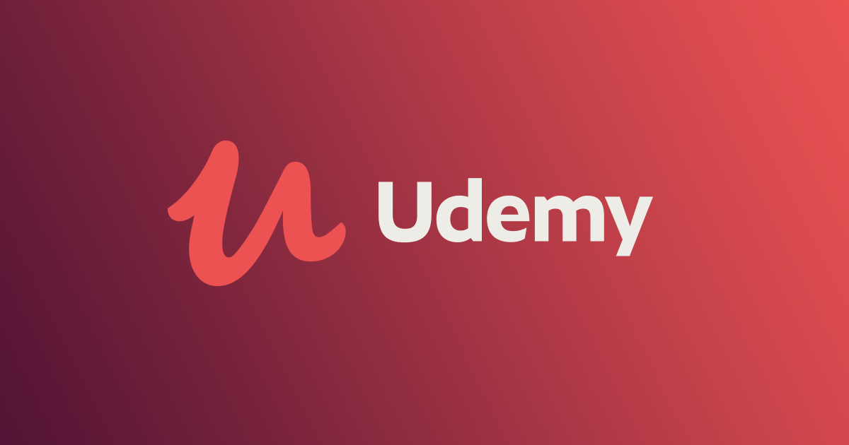.

[Founded](https://www.google.com/search?client=firefox-b-d&sxsrf=ALeKk01HMtFclXu8b8zq_1MZiKJRfVDz_w:1598038251940&q=udemy+founded&stick=H4sIAAAAAAAAAOPgE-LSz9U3KKoqMogv01LNTrbSzy9KT8zLrEosyczPQ-FYpeWX5qWkpixi5S1NSc2tVIDyAR7TyqZFAAAA&sa=X&ved=2ahUKEwjikOCyhK3rAhXUmuYKHfteASwQ6BMoADAYegQIExAC): 2009

[CEO](https://www.google.com/search?client=firefox-b-d&sxsrf=ALeKk01HMtFclXu8b8zq_1MZiKJRfVDz_w:1598038251940&q=udemy+ceo&stick=H4sIAAAAAAAAAOPgE-LSz9U3KKoqMogv01LMTrbSzy9KT8zLrEosyczPQ-FYJafmL2LlLE1Jza1UALIBhFDKuD0AAAA&sa=X&ved=2ahUKEwjikOCyhK3rAhXUmuYKHfteASwQ6BMoADAZegQIFBAC): [Gregg Coccari](https://www.google.com/search?client=firefox-b-d&sxsrf=ALeKk01HMtFclXu8b8zq_1MZiKJRfVDz_w:1598038251940&q=Gregg+Coccari&stick=H4sIAAAAAAAAAOPgE-LSz9U3KKoqMogvU-LVT9c3NEwzMMyyNEqO11LMTrbSzy9KT8zLrEosyczPQ-FYJafmL2LldS9KTU9XcM5PTk4sytzByggAZnzJCFMAAAA&sa=X&ved=2ahUKEwjikOCyhK3rAhXUmuYKHfteASwQmxMoATAZegQIFBAD) (5 Feb 2019–)

[Headquarters](https://www.google.com/search?client=firefox-b-d&sxsrf=ALeKk01HMtFclXu8b8zq_1MZiKJRfVDz_w:1598038251940&q=udemy+headquarters&stick=H4sIAAAAAAAAAOPgE-LSz9U3KKoqMogv09LKTrbSzy9KT8zLrEosyczPQ-FYZaQmphSWJhaVpBYVL2IVKk1Jza1UQBYEAFkYlTBPAAAA&sa=X&ved=2ahUKEwjikOCyhK3rAhXUmuYKHfteASwQ6BMoADAaegQIGBAC): [San Francisco, California, United States](https://www.google.com/search?client=firefox-b-d&sxsrf=ALeKk01HMtFclXu8b8zq_1MZiKJRfVDz_w:1598038251940&q=San+Francisco&stick=H4sIAAAAAAAAAOPgE-LSz9U3KKoqMogvU-IAsVPMcgq0tLKTrfTzi9IT8zKrEksy8_NQOFYZqYkphaWJRSWpRcWLWHmDE_MU3IoS85Izi5Pzd7AyAgDU9ARIVwAAAA&sa=X&ved=2ahUKEwjikOCyhK3rAhXUmuYKHfteASwQmxMoATAaegQIGBAD)

[Founders](https://www.google.com/search?client=firefox-b-d&sxsrf=ALeKk01HMtFclXu8b8zq_1MZiKJRfVDz_w:1598038251940&q=udemy+founders&stick=H4sIAAAAAAAAAOPgE-LSz9U3KKoqMogv01LPTrbSTyotzsxLLS6GM-LzC1KLEksy8_Os0vJL81JSixax8pWmpOZWKkD5xQDN2rjQSAAAAA&sa=X&ved=2ahUKEwjikOCyhK3rAhXUmuYKHfteASwQ6BMoADAbegQIFhAC): [Eren Bali](https://www.google.com/search?client=firefox-b-d&sxsrf=ALeKk01HMtFclXu8b8zq_1MZiKJRfVDz_w:1598038251940&q=Eren+Bali&stick=H4sIAAAAAAAAAOPgE-LSz9U3KKoqMogvU4KxTU2KtdSzk630k0qLM_NSi4vhjPj8gtSixJLM_DyrtPzSvJTUokWsnK5FqXkKTok5mTtYGQG8ZUkbUgAAAA&sa=X&ved=2ahUKEwjikOCyhK3rAhXUmuYKHfteASwQmxMoATAbegQIFhAD), [Oktay Caglar](https://www.google.com/search?client=firefox-b-d&sxsrf=ALeKk01HMtFclXu8b8zq_1MZiKJRfVDz_w:1598038251940&q=Oktay+Caglar&stick=H4sIAAAAAAAAAOPgE-LSz9U3KKoqMogvU4KxTU1NtdSzk630k0qLM_NSi4vhjPj8gtSixJLM_DyrtPzSvJTUokWsPP7ZJYmVCs6J6TmJRTtYGQFjA3bEVQAAAA&sa=X&ved=2ahUKEwjikOCyhK3rAhXUmuYKHfteASwQmxMoAjAbegQIFhAE), [Gagan Biyani](https://www.google.com/search?client=firefox-b-d&sxsrf=ALeKk01HMtFclXu8b8zq_1MZiKJRfVDz_w:1598038251940&q=Gagan+Biyani&stick=H4sIAAAAAAAAAOPgE-LSz9U3KKoqMogvU4KxTU0rtdSzk630k0qLM_NSi4vhjPj8gtSixJLM_DyrtPzSvJTUokWsPO6J6Yl5Ck6ZlYl5mTtYGQG4r2sMVQAAAA&sa=X&ved=2ahUKEwjikOCyhK3rAhXUmuYKHfteASwQmxMoAzAbegQIFhAF)

[Subsidiary](https://www.google.com/search?client=firefox-b-d&sxsrf=ALeKk01HMtFclXu8b8zq_1MZiKJRfVDz_w:1598038251940&q=udemy+subsidiary&stick=H4sIAAAAAAAAAOPgE-LSz9U3KKoqMogv09LMKLfST87PyUlNLsnMz9PPL0pPzMusSgRxiq2KS5OKM1MyE4syU4sXsQqUpqTmVirABSsBmXrdNEwAAAA&sa=X&ved=2ahUKEwjikOCyhK3rAhXUmuYKHfteASwQ6BMoADAcegQIEBAC): [Sunnytrail Insight Labs Inc.](https://www.google.com/search?client=firefox-b-d&sxsrf=ALeKk01HMtFclXu8b8zq_1MZiKJRfVDz_w:1598038251940&q=Sunnytrail+Insight+Labs+Inc.&stick=H4sIAAAAAAAAAOPgE-LSz9U3KKoqMogvU-LVT9c3NEyrNCzPy0kz1dLMKLfST87PyUlNLsnMz9PPL0pPzMusSgRxiq2KS5OKM1MyE4syU4sXscoEl-blVZYUJWbmKHjmFWemZ5Qo-CQmFQM5yXo7WBkBFW02uGoAAAA&sa=X&ved=2ahUKEwjikOCyhK3rAhXUmuYKHfteASwQmxMoATAcegQIEBAD)

Students take courses largely as a means of improving job-related skills. Some courses generate credit toward technical certification. Udemy has made a special effort to attract corporate trainers seeking to create coursework for employees of their company. As of 2020, there are more than 150,000 courses on the website.

In April 2013, Udemy offered an app for Apple IOS, allowing students to take classes directly from iPhones; The Android version was launched in January 2014.As of January 2014, the iOS app had been downloaded over 1 million times, and 20 percent of Udemy users access their courses via mobile. In July 2016, Udemy expanded their iOS platform to include Apple TV.On January 11, 2020, the Udemy mobile app became the #1 top grossing Android app in India.

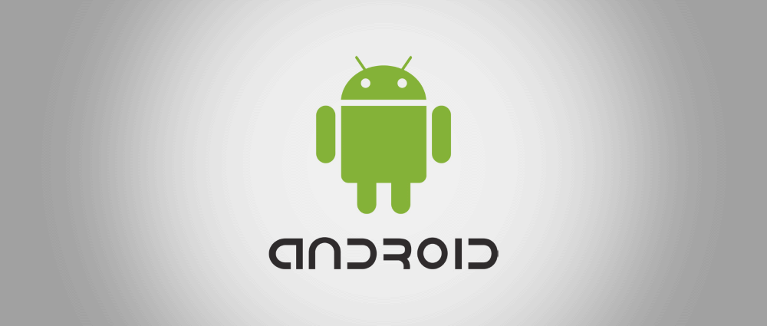

Fig. 1.2

**1.2** **ANDROID – AN OPERATING SYSTEM**

Android, Inc. was founded in October 2003 California by the efforts of Andy Rubin who was co-founder of Danger, Rich Miner who was co-founder of Wildfire Communications, Inc.,  Nick Sears was once VP at T-Mobile, and Chris White which headed design & interface development of WebTV. The motive of the company was to develop an advanced operating system which can be used digital cameras, but when they realised that the market required for that was not large enough to capture, and they diverted their efforts in producing the operating system which to rival Symbian and others. Despite the founders past accomplishments, Android Inc. secretly operated, revealing it was working on mobile phones software. Google buys out Android Inc. on 17 August 2005. Android Inc. key employees- Rubin Miner and White stayed in the company after the google acquisition. Many assumed that android Inc. at that time was planned to enter the market of mobile phone. At Android team led by Rubin developed Linux kernel powered mobile phone operating system. Google demonstrated the operating system to handset makers and carriers with the vision of  providing a flexible & upgradable system. The Google has taken a series of h/w component and s/w partners and signalled to carriers that they are open up more co-operation.

 On 5 November 2007 Android’s powered mobile device platform built on the Linux kernel version 2.6.25 is launched. HTC Dream was first commercially available android powered Smartphone released on October 22, 2008.

**1.3 ARCHITECTURE OF ANDROID SYSTEM**

**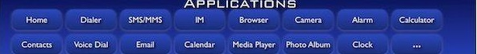**

**Fig. 1.3 APPLICATION**

**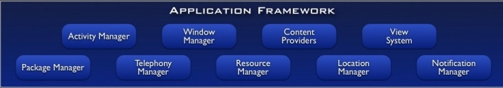**

**Fig. 1.4 APPLICATION FRAMEWORK**

**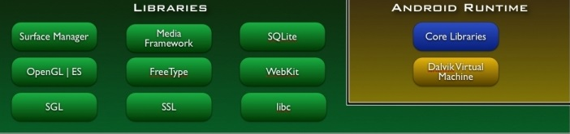**

**Fig. 1.5 LIBRARIES / ANDROID RUNTIME**

**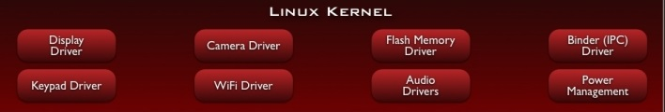**

**Fig. 1.6 LINUX KERNEL**

**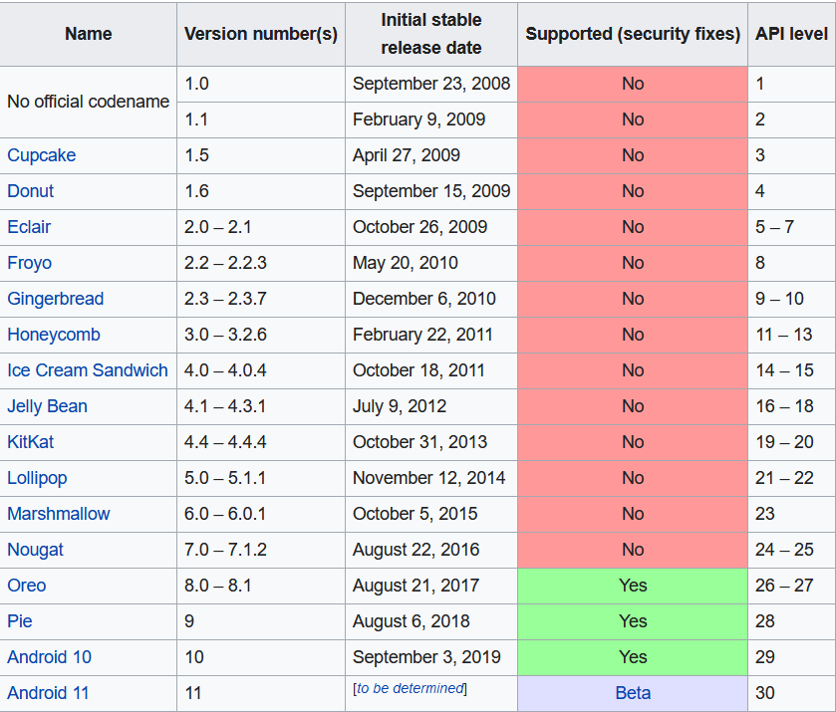**

**Fig. 1.7 ANDROID VERSIONS**

**1.4 ANDROID OREO**

**Fig 1.8**

**Android Oreo** (codenamed **Android O** during development) is the eighth major release and the 15th version of the Android mobile operating system. It was first released as an alpha quality developer preview in March 2017 and released to the public on August 21, 2017.

It contains a number of major features, including notification grouping, picture-in-picture support for video, performance improvements and battery usage optimization, and support for autofillers, Bluetooth 5, system-level integration with VoIP apps, wide color gamuts, and Wi-Fi Aware. Android Oreo also introduces two major platform features: Android Go – a software distribution of the operating system for low-end devices – and support for implementing a hardware abstraction layer.

As of July 2020, 18.5% of Android devices run Oreo, with 7% on Android 8.0 (API 26) and 11.5% using Android 8.1 (API 27), Android 8.1 is behind Android 10, by now the third still popular version.

**1.5 PROJECT**

The Course Android Oreo App Development deals with the idea of creating Apps. Throughout the course we learn various like Android Studio , Features of Android , GDX tool , Eco web Hosting and many more.

I also used the older Android Studio 3.0.1 version throughout as it's a great introduction to the development environment.

Throughout the course I tried to create several apps like Bluetooth, Super Mario clone, Twitter clone and many more. We will go through the several other features like ARcore and will create a website using Eco Web Hosting and WordPress for the marketing of our app.

**1.6 GOAL OF PROPOSED COURSE**

Whether you’re looking to usher in the next generation of smart TVs, fitness wearables, games consoles, game-changing AI, smartwatches or just build simple apps for good old fashioned fun -- Android 8.0 Oreo is your key to unbridled creativity.

Fresh from Google’s workshop, Android 8.0 Oreo is stable, feature-rich and functional as ever. Not only can you develop more efficiently, but you’ll get new ways to extend your app.

**1.7 SOFTWARE USED**

Throughout the course I used several softwares Like Android Studio and Vysor.

**1.7.1 ANDROID STUDIO**

**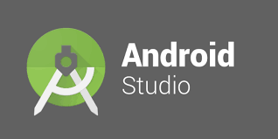**

**Fig. 1.9**

**Android Studio** is the official integrated development environment (IDE) for Google's Android operating system, built on Jet Brains' IntelliJ IDEA software and designed specifically for Android development.It is available for download on Windows, macOS and Linux based operating systems or as a subscription-based service in 2020. It is a replacement for the Eclipse Android Development Tools (E-ADT) as the primary IDE for native Android application development.

Android Studio was announced on May 16, 2013 at the Google I/O conference. It was in early access preview stage starting from version 0.1 in May 2013, then entered beta stage starting from version 0.8 which was released in June 2014. The first stable build was released in December 2014, starting from version 1.0.

On May 7, 2019, Kotlin replaced Java as Google's preferred language for Android app development. Java is still supported, as is C++.

The following features are provided in the current stable version:

* Gradle-based build support
* Android-specific refactoring and quick fixes
* Lint tools to catch performance, usability, version compatibility and other problems
* ProGuard integration and app-signing capabilities
* Template-based wizards to create common Android designs and components
* A rich layout editor that allows users to drag-and-drop UI components, option to preview layouts on multiple screen configurations.
* Support for building Android Wear apps
* Built-in support for Google Cloud Platform, enabling integration with Firebase Cloud Messaging (Earlier 'Google Cloud Messaging') and Google App Engine.
* Android Virtual Device (Emulator) to run and debug apps in the Android studio.

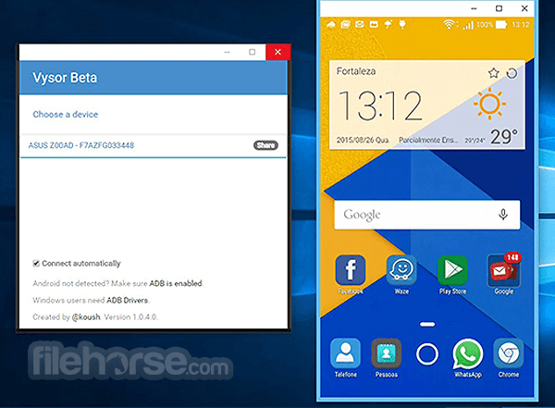**1.7.2 VYSOR**

**Fig 1.10**

Vysor is an extension for the Google Chrome browser that connects to an app on your smartphone, enabling you to control your phone from your PC or Mac using the mouse/trackpad and keyboard. Everything happens via a USB cable, which you’ll need to connect the phone to your computer’s USB port.

Vysor runs in two modes, one free and one paid for. In the free version you can run at a modest screen resolution and take screenshots; in the paid version the screen resolution is higher, you can run in full screen mode, you can drag and drop files and you can connect via Wi-Fi.

To install Vysor you’ll need to do two things: install the Vysor app on your phone and install the Vysor extension for Chrome. The Google browser is a must-have for the Vysor extension, and you won’t be able to control your phone without it. If your computer is Windows, you’ll also need to install the drivers for Active Debugging.

On your smartphone, install the Vysor app and enable USB debugging (if it isn’t already enabled): to do that you’ll need to activate developer mode by tapping seven times on the build number listed under Device Information.

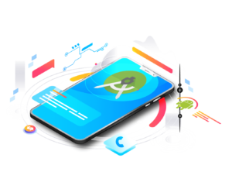**1.8 TOOLS USED**

**1.8.1 ANDROID SDK**

**Fig. 1.11**

Every time Google releases a new version, the corresponding SDK is also released. In order to work with Android, the developers must download and install each version’s SDK for the particular device.

The Android SDK (Software Development Kit) is a set of development tools that are used to develop applications for the Android platform.

This SDK provides a selection of tools that are required to build Android applications and ensures the process goes as smoothly as possible. Whether you create an application using Java, Kotlin or C#, you need the SDK to get it to run on any Android device. You can also use an emulator in order to test the applications that you have built.

Nowadays, the Android SDK also comes bundled with Android Studio, the integrated development environment where the work gets done and many of the tools are now best accessed or managed

**SOFTWARE USED WITH REQIREMENTS:**

**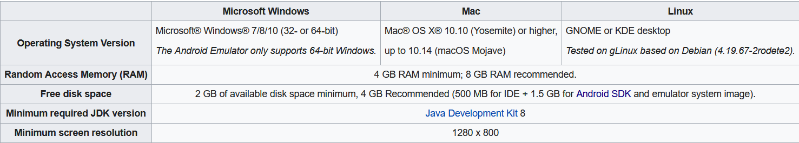 Android Studio:**

**Fig 1.12**

**Vysor:**

For Vysor there are only few system requirements.

### **Specifications**

OS: Windows

Language: English

License: Free

Developer: ClockworkMod

**HARDWARE REQUIREMENT:**

**Your development workstation should meet or exceed these hardware requirements:**

* A 64-bit environment is required for Android 2.3.
* At least 250GB of free disk space to check out the code and an extra 150 GB to build it.
* If you're running Linux in a virtual machine, you need at least 16 GB of **RAM**/swap.

**Andvanced Android Features**

**List View:**

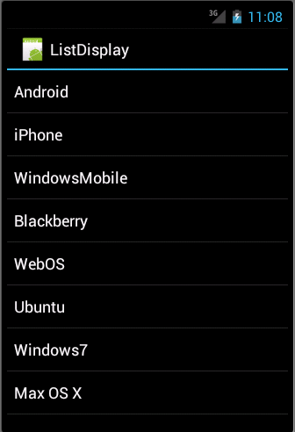Android **ListView** is a view which groups several items and display them in vertical scrollable list. The list items are automatically inserted to the list using an **Adapter** that pulls content from a source such as an array or database.

**Fig 1.13**

An adapter actually bridges between UI components and the data source that fill data into UI Component. Adapter holds the data and send the data to adapter view, the view can takes the data from adapter view and shows the data on different views like as spinner, list view, grid view etc.

The **ListView** and **GridView** are subclasses of **AdapterView** and they can be populated by binding them to an **Adapter**, which retrieves data from an external source and creates a View that represents each data entry.

Following is the code for making an App to show ListView:

**package** com.example.myapplication1  
import androidx.appcompat.app.AppCompatActivity  
import android.os.Bundle  
  
**class** MainActivity : AppCompatActivity() {  
 @override   
 protected void onCreate(Bundle savedInstanceState) {  
 **super**.onCreate(savedInstanceState)  
 setContentView(R.layout.activity\_main);  
 ListView myListView = findViewById(R.id.myListView);

myFamily.add(**"Vishal"**);  
 myFamily.add(**"Harshit"**);  
 myFamily.add(**“Ayush"**);  
 myFamily.add(**"Vansh"**)

ArrayList<String> myFamily = new ArrayList<String>();

ArrayAdapter<String> arrayAdapter = new ArrayAdapter<String>( context: **this**, android.R.layout.simple\_list\_item\_1, myFamily);  
   
 myListView.setAdapter(arrayAdapter);  
   
 }  
}

**CREATING BLUETOOTH APP**

Bluetooth is a wireless technology standard used for exchanging data between fixed and mobile devices over short distances using short-wavelength UHF radio waves in the industrial, scientific and medical radio bands, from 2.402 GHz to 2.480 GHz, and building personal area networks (PANs).

More than just a radio technology, Bluetooth provides full stack, fit-for-purpose solutions to meet the ever-expanding needs for wireless connectivity.

**STEPS:**

1. Creating a Bluetooth device requires the latest version Of Android Studio. Here I used Android Studio 4.0.
2. I started my project with the name Bluetooth Finder (you may give the name to your app as per your interest). So let’s get started with this Bluetooth Finder.
3. You need First of all attach a physical android device so that you can check the functionality of your working Bluetooth device. I personally have my API 22: Android 5.1(Lollipop) where I checked the functionality of my app.
4. We will be start by setting a button which will be named as search that will help as to search for nearby devices available when pressed.
5. With this I there would be a TextView that will say the current state of what going on.
6. And then we will have a ListView.

**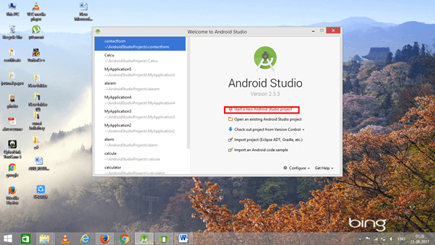**

**Fig 1.14**

**Following is the code for the App:**

**package** com.example.bluetoothfinder1;  
  
**import** androidx.appcompat.app.AppCompatActivity;  
  
**import** android.bluetooth.BluetoothAdapter;  
**import** android.bluetooth.BluetoothDevice;  
**import** android.content.BroadcastReceiver;  
**import** android.content.Context;  
**import** android.content.Intent;  
**import** android.content.IntentFilter;  
**import** android.os.Bundle;  
**import** android.util.Log;  
**import** android.view.View;  
**import** android.widget.Button;  
**import** android.widget.ListView;  
**import** android.widget.TextView;  
  
**public class** MainActivity **extends** AppCompatActivity {  
  
 ListView **listView**;  
 TextView **statusTextView**;  
 Button **searchButton**;  
 BluetoothAdapter **bluetoothAdapter**;  
  
 **private final** BroadcastReceiver **broadcastReceiver** = **new** BroadcastReceiver() {  
 @Override  
 **public void** onReceive(Context context, Intent intent) {  
 String action = intent.getAction();  
 Log.*i*( **"Action"**, action);  
 }  
 };

**public void** searchClicked(View view){  
 **statusTextView**.setText(**"Searching...."**);  
 **searchButton**.setEnabled(**false**);  
 }  
  
 @Override  
 **protected void** onCreate(Bundle savedInstanceState) {  
 **super**.onCreate(savedInstanceState);  
 setContentView(R.layout.***activity\_main***);  
  
 **listView** = findViewById(R.id.***listView***);  
 **statusTextView** = findViewById(R.id.***statusTextView***);  
 **searchButton** = findViewById(R.id.***searchButton***);  
  
 **bluetoothAdapter** = BluetoothAdapter.*getDefaultAdapter*();  
 IntentFilter intentFilter = **new** IntentFilter();  
 intentFilter.addAction(BluetoothAdapter.***ACTION\_STATE\_CHANGED***);  
 intentFilter.addAction(BluetoothDevice.***ACTION\_FOUND***);  
 intentFilter.addAction(BluetoothAdapter.***ACTION\_DISCOVERY\_STARTED***);  
 intentFilter.addAction(BluetoothAdapter.***ACTION\_DISCOVERY\_FINISHED***);  
 registerReceiver(**broadcastReceiver**, intentFilter);  
  
  
 **bluetoothAdapter**.startDiscovery();  
 }  
}

Following is the Output Console Image of the physical device that is used as Emulator to check for the App.

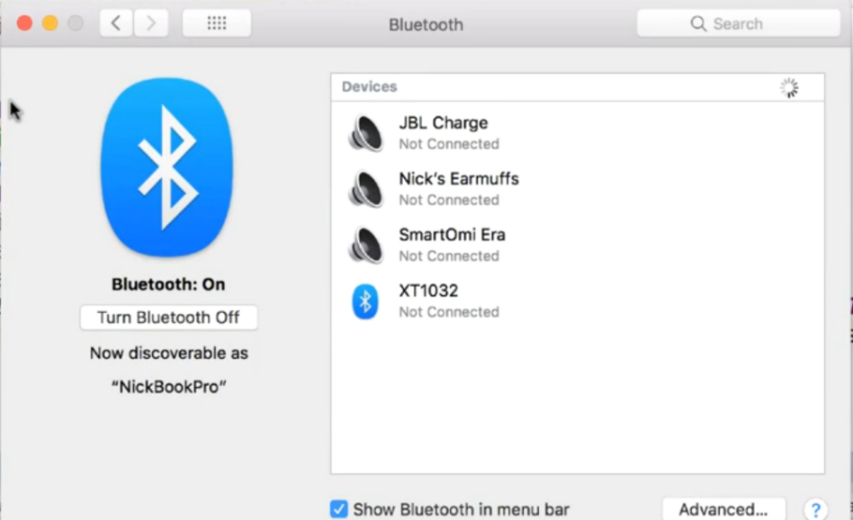

**Fig 1. 15**

**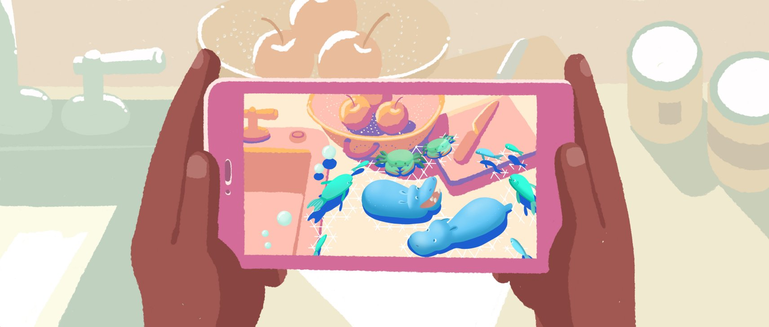ARcore**

**Fig 1. 16**

ARCore is Google’s platform for building augmented reality experiences. Using different APIs, ARCore enables your phone to sense its environment, understand the world and interact with information. Some of the APIs are available across Android and iOS to enable shared AR experiences.

ARCore uses three key capabilities to integrate virtual content with the real world as seen through your phone's camera:

1. Motion tracking allows the phone to understand and track its position relative to the world.
2. Environmental understanding allows the phone to detect the size and location of all type of surfaces: horizontal, vertical and angled surfaces like the ground, a coffee table or walls.
3. Light estimation allows the phone to estimate the environment's current lighting conditions.

Technology such as ARCore’s Light Estimation API lets your digital objects appear realistically — as if they’re actually part of the physical world. And with ARCore Elements — a set of common AR UI components that have been validated with user testing — you can insert AR interactive patterns in your apps without having to reinvent the wheel.

**APP MARKETING:**

Imagine u spend all your time making of any useful App with cool features but no one hardly uses it just because lack of knowledge about the app. So App marketing is equally important as the App building.

Some of the Basics of App Marketing:

1. Draw out entire app before ANYTHING.

2. Whether you Building or Buying things for the App.

3. Monetization for the App.

3.1 Purchase

3.2 ADS

3.3 In-App Purchases

1. Tell a story with your App
2. Get Friends to test usability

**CREATING WEBSITE FOR MARKETING**

Here we will set up a marketing website using Eco Web Hosting Account and WordPress.ORG which will help us designing without any knowledge of HTML or JAVA Script or any sort of coding.

First of all I created a account on Eco web Hosting which I got free with the my course.

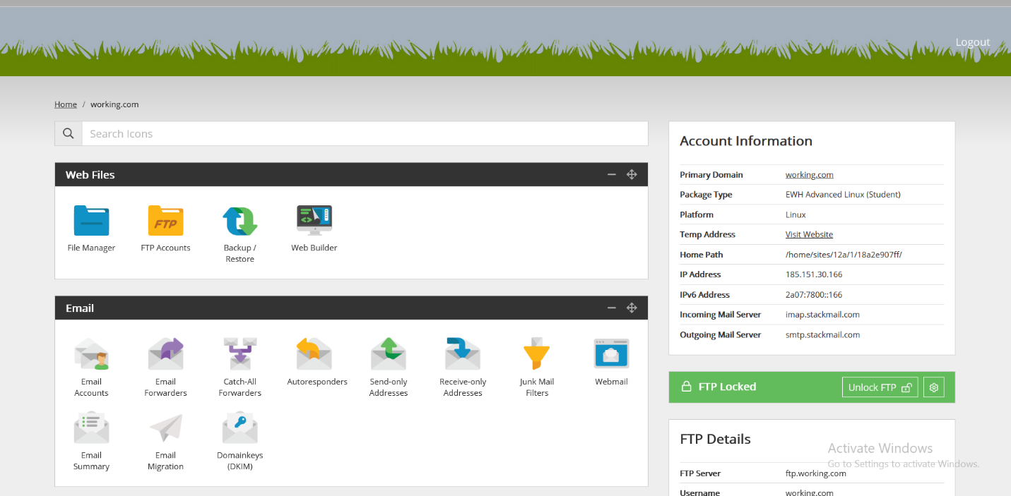 **Fig 1.17**

1. First of all I need to create a Hosting Package which adds a Domain name to my account. I created a Domain name working.com.
2. You don’t need to own the Domain name because for that you need to purchase it for around 7 Pounds a year depending on the Domain.
3. After setting Domain than you can move to your Cpanel (Control Panel).
4. From there you need to go for CGI scripts where you need to go For WordPress where you need to create location.
5. After that you will be directed to stackstaging page where you can edit , design or customize your web page.
6. Make sure to Update your WordPress Version as it is most used website so it is very liberal to be get hacked.
7. Then we need go to Pages option where we will be spending our most of the time designing and enhancing our website.

**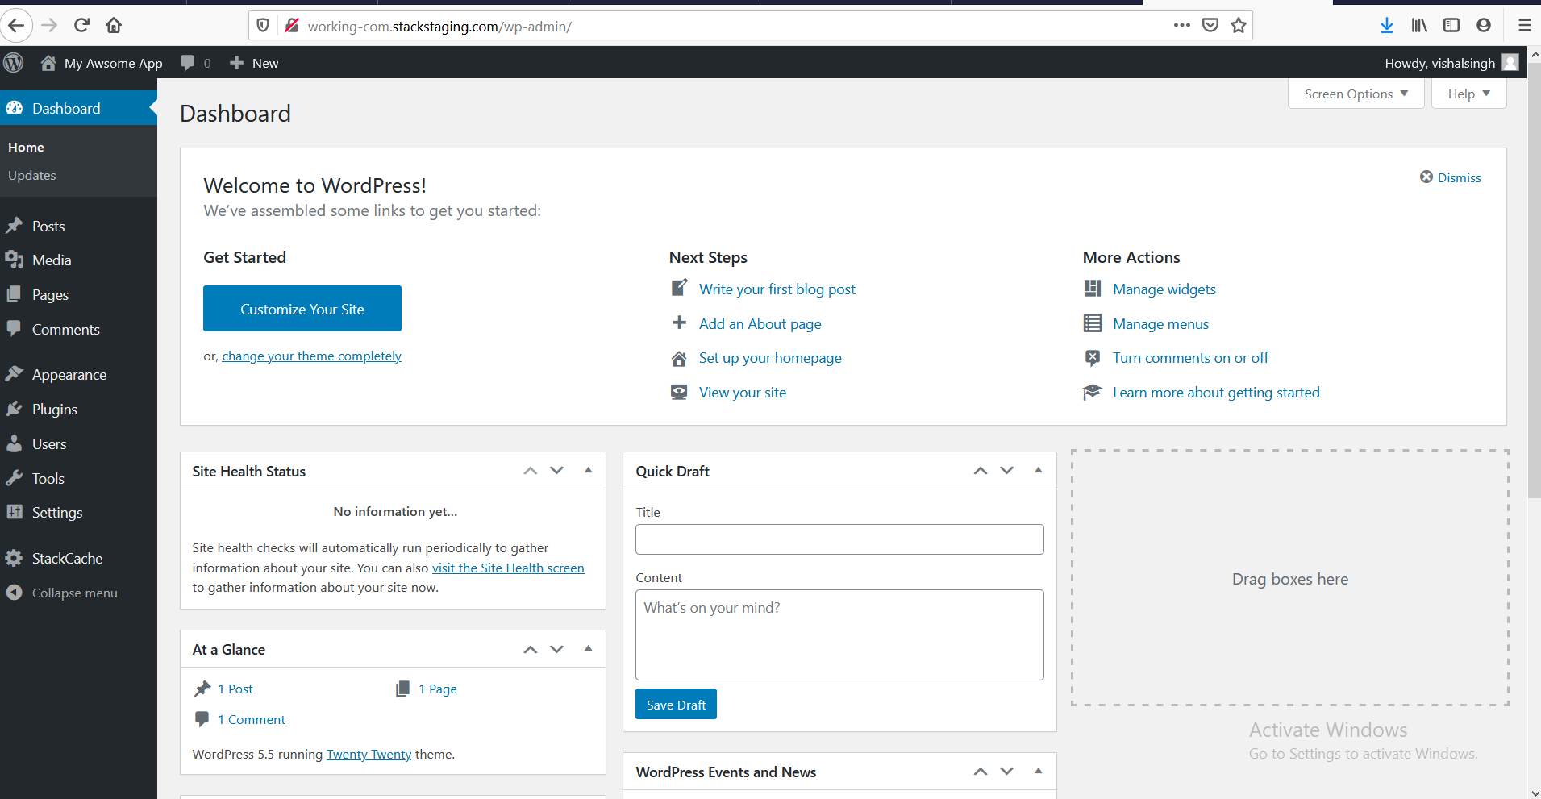 Fig 1.18**

1. Pages are designed for more static content rather than blog post.
2. We need to set a theme for our website. I preferred appzthemeshaker.com for downloading themes for me

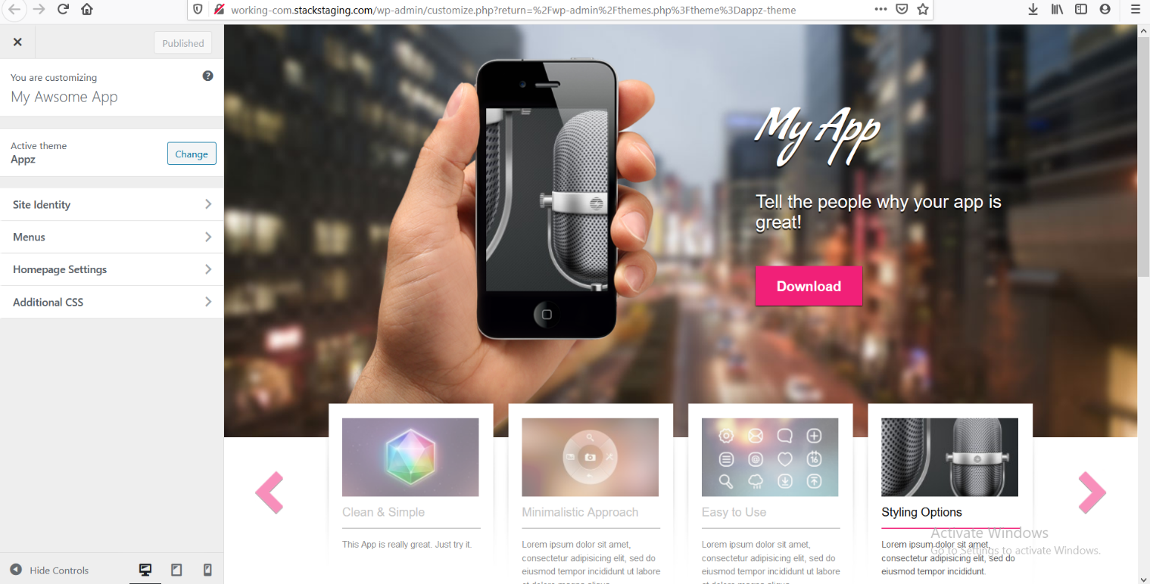 **Fig. 1.19**

The picture shown above is the customize website created by me.

**CONCLUSION:**

The course titled ANDROID OREO APP DEVELOPMENT is an android app development course. The aim of the course was to learn how to develop apps using Android Studio software.

The course was successfully completed by which covering maximum requirement given by the Mentor. The course is quiet effective and was very helpful for learning purpose.

Android is truly open, free development platform based on Linux and open source. Handset users can make customize apps according to their needs.

Throughout the course I got to know various new methods to enhance software and it’s compability.

Android 8.0 Oreo is stable, feature-rich and functional as ever. Not only can you develop more efficiently, but you’ll get new ways to extend your app.

All you need is the right idea, or that lucky bit of exposure -- and your ‘big break’ might just be around the corner.

Whether you’re looking to usher in the next generation of smart TVs, fitness wearables, games consoles, game-changing AI, smartwatches -- or just build simple apps for good old fashioned fun -- Android 8.0 Oreo is your key to unbridled creativity.

**REFERENCES:**

[1] Getting Started with Android referred from developer.android.com/.

[2] J. F. DiMarzio[,](http://www.flipkart.com/author/j-f-dimarzio" \t "_blank) “Android - A Programmer's Guide 1st Edition”, 2010, Tata McGraw - Hill Education ISBN 9780071070591.

[3] Ed Burnette, “Hello, Android: Introducing Google's Mobile Development Platform 3rd Edition”, 2011, Pragamatic publications.

[4] Reto Meier,  “Professional Android 4 Application Development”, 2012, Wiley India.

[5] Referred the book written by Roger Pressman, titled Software Engineering - a  practitioner's approach.

[6] Gerhard Fischer, "The Software Technology of the 21st Century: From Software Reuse to Collaborative Software Design"

[7] K.K.Aggarwal & Yogesh Singh, “Software Engineering”, 2013, New Age International

Publication.

[8] Udemy

[9] Wikipedia.com

**FUTURE PROSPECTS:**

The Future Prospects are as follows: Applications in Android platform are growing at unimaginably high pace. Android has rapidly become the fastest-growing mobile OS with largest installed base. Every day more than

900,000 new Android devices are activated worldwide. Android’s openness has made it a favorite for consumers and developers alike, driving strong growth in app consumption. Android users download more than 1 billion apps and games from Google Play each month. With its partners, Android is continuously pushing the boundaries of hardware and software forward to bring new capabilities to users and developers. For developers, Android innovation lets us build powerful, differentiated applications that use the latest mobile technologies. Google Play is the premier marketplace for distributing Android apps I propose to continue my development activities in Android, Java to be part of the ongoing Innovations happening in the Industry. I also would seek to found a company to slowly build on Android development leveraging Google App Engine.